**INTRODUCTION:**



A software requirements specification (SRS) is a document that describes what the software will do and how it will be expected to perform. It also describes the functionality of the product needs to fulfil all stakeholders (business, users) needs.

It includes set of use cases that describes all interactions the users will have with the software, that is it includes a set of functional and Non functional requirements.

It is the description of the software system to be developed.

It describes how a product will work.

A typical SRS includes:

• A purpose

• An overall description

• Specific requirements

**PURPOUSE OF SRS DOCUMENT:**

In short, the purpose of this SRS document is to provide a detailed overview of our software product and its parameters and goals

We are building a Software that helps the customer to purchase or renting the toys.

Intended Audience and Intended Use:

how they should use it. This may include developers, testers, and project managers. It could also include stakeholders in other departments, including leadership teams, sales, and marketing.

**How to write the SRS document**

• Define the purpose of product.

• Describe about software building.

• Detail the requirements.

• Get it approved.

**Intended Audience and Intended Use:**

As this documents is containing all the basic requirements of the software, it can be deployed in any area where such kind of situation occurs.This SRS is mainly developed for the project development team. In this team there are the project manager,developer, coder, tester and documentation writer and the user of the project also. It can also be used by stakeholders in other departments, including leadership teams, sales and marketing.

**Project Manager**

This SRS document is also very important for the project manager to ensure that can estimate the cost easily by referring to the SRS document and that it contains all the information require planning the project.

**Project Developer**

The project developer will refer to the SRS document to make sure that they developed

exactly that the customer requires.

**Tester**

The tester will read this SRS document and he will ensure that the requirements

are understandable from functionality point of view so that he can test the software and validate its working.

**Document Writer**

The document writer is reading the SRS document is to ensure that theyunderstand the document well enough to be able to write the users manuals.

**Maintenance**

The SRS document helps the maintenance engineers to understand functionality of the system, a clear knowledge of the functionality can help them to understand design and code.

**Scope**

The Software Requirements Specification captures all the requirements in a single document.

Need to describe the software being specified

It must include benefits, objectives and goals

This Should also relate to overall business goals

It’s smart to include a risk definition. Avoiding risk is top-of-mind for many developers

Ex : Toys

Overview of What You’ll Build

Your next step is to give a description of what you’re going to build. Is it an update to an existing product? Is it a new product? Is it an add-on to a product you’ve already created?

These are important to describe upfront, so everyone knows what you’re building.

You should also describe why you’re building it and who it’s for.

**User Needs**

User needs are critical. You’ll need to define who is going to use the product and how.

You’ll have primary and secondary users who will use the product on a regular basis. You may also need to define the needs of a separate buyer of the product (who may not be a primary/secondary user). And, for example, if you’re building a medical device, you’ll need to describe the patient’s needs.

Assumptions and Dependencies

There might be factors that impact your ability to fulfill the requirements outlined in your SRS. What are those factors?

Are there any assumptions you’re making with the SRS that could turn out to be false? You should include those here, as well.

Finally, you should note if your project is dependent on any external factors. This might include software components you’re reusing from another project.

**System Feature**

**1. Correctness of Software Requirement Specification should be checked**. Since the whole testing phase is dependent on SRS, it is very important to check its correctness. There are some standards with which we can compare and verify.

2. **Ambiguity should be avoided.** Sometimes in SRS, some words have more than one meaning and this might confused testers making it difficult to get the exact reference. It is advisable to check for such ambiguous words and make the meaning clear for better understanding.

3. **Requirements should be complete**. When tester writes test cases, what exactly is required from the application, is the first thing which needs to be clear. For e.g. if application needs to send the specific data of some specific size then it should be clearly mentioned in SRS that how much data and what is the size limit to send.

4. **Consistent requirements.** The SRS should be consistent within itself and consistent to its reference documents. If you call an input “Start and Stop” in one place, don’t call it “Start/Stop” in another. This sets the standard and should be followed throughout the testing phase.

**5. Verification of expected result:** Software Requirement Specification should not have statements like “Work as expected”, it should be clearly stated that what is expected since different testers would have different thinking aspects and may draw different results from this statement.

6. **Testing environment:** some applications need specific conditions to test and also a particular environment for accurate result. SRS should have clear documentation on what type of environment is needed to set up.

7. **Pre-conditions defined clearly:** one of the most important part of test cases is pre-conditions. If they are not met properly then actual result will always be different expected result. Verify that in SRS, all the pre-conditions are mentioned clearly.

8. **Security and Performance criteria**: security is priority when a software is tested especially when it is built in such a way that it contains some crucial information when leaked can cause harm to business. Tester should check that all the security related requirements are properly defined and are clear to him. Also, when we talk about performance of a software, it plays a very important role in business so all the requirements related to performance must be clear to the tester and he must also know when and how much stress or load testing should be done to test the performance.

9. **Assumption should be avoided:** sometimes when requirement is not cleared to tester, he tends to make some assumptions related to it, which is not a right way to do testing as assumptions could go wrong and hence, test results may vary. It is better to avoid assumptions and ask clients about all the “missing requirements” to have a better understanding of expected results.

10**. Deletion of irrelevant requirements:** there are more than one team who work on SRS so it might be possible that some irrelevant requirements are included in SRS. Based on the understanding of the software, tester can find out which are these requirements and remove them to avoid confusions and reduce work load.

**FUNCTIONAL REQUIREMENT**

Main page will show different toys, categories list etc.

Ø Sing Up/ Login Page: Signup page will be used to register a visitor of website.

Ø Preview Page: When user/visitor clicks on any item, a new page for the details of the item should be shown to user/visitor.

Ø Video preview: There must be a video preview available to user/visitor on Preview page. A short video for the selected item should be played for user/visitor.

Ø A visitor is a non-registered user of the website.

Ø Can view different toys and can explore different categories

Ø Can register to the website using Signup page in order to make a purchase.

Ø User can view the information about toys.

Ø Add different toys to the shopping cart.

Ø Buyer will have to fill a form for required details needed to confirm the order.

Ø A buyer can cancel an order before confirmation or can check-out from the main page.

Ø After collecting toys, a buyer can write feedback on webpage.

Ø Updates toys information

Ø Manages toys repository

Ø Generates reports from system

Ø Manages categories of toys

Ø Online payments e.g credit/debit card, online vouchers can be implemented later.

Ø Return policies might be defined as per needed.

**External interface Requirements**

* User interfaces
* Hardware interfaces
* Software interfaces

**User interface:**

* Design
* Interactive
* This software will be easy understandable and operable to user.

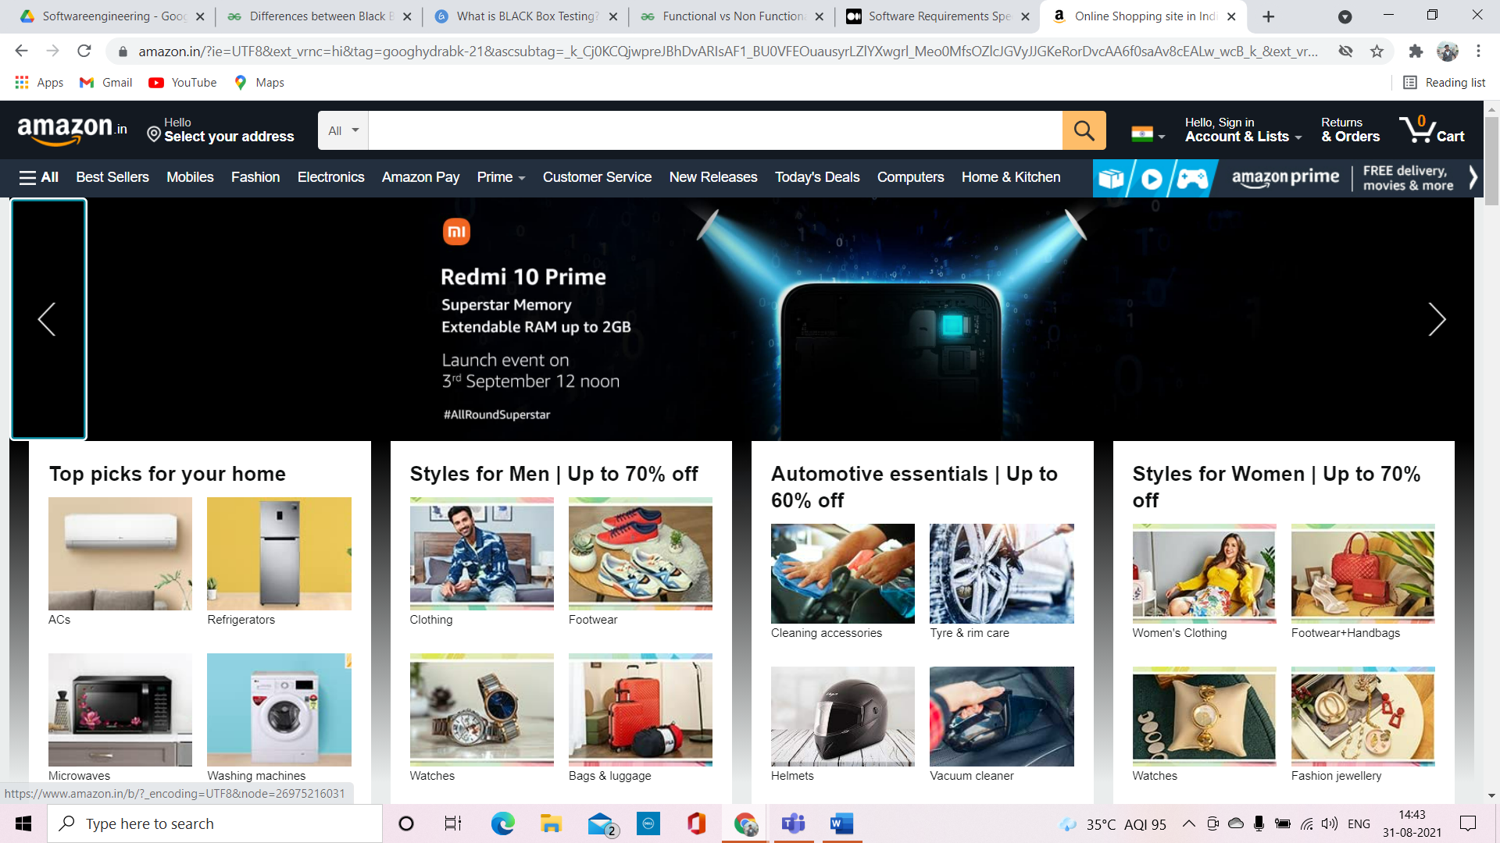

**Software Interface:**

* Windows, Macand Linux operating systems
* SMTP email
* Firewall
* IP network protocols and
* the software drivers that activate the peripheral devices.

**Hardware Interface:**

* USB
* Micro processor
* Ethernet
* Printers
* PCB board

**Non Functional Requirements**

PERFORMANCE REQIREMENT

E-R DIAGRAM

SAFETY REQIREMENT

SECURITY REQIREMENT

SOFTWARE QUALITY ATTRIBUTES

AVAILABILITY

CORRECTNESS

MAINTAINABILITY

USABILITY

User Friendly:

Online Store for Toys Shopping will be a user-friendly system for all the users, its interface designed to keep the understanding level of a common user.

Reliability:

Online Store for Toys Shopping is a reliable system and it is able to meet all the needs and expectations of the user.

Maintainability:

Online Store for Toys Shopping will design in such a way that in future it would be easy to maintain carries out further extension in the system.

Performance:

Online Store for Toys Shopping performance will be the criteria that will describe the success of the system so, by knowing this fact this system is designed so that it can achieve high levels of performance. This system is able to respond all users in less than five seconds.

Fault Tolerance:

This system is able to recover from failures so, whenever failure will occur system will recover from the failure.

Security/data integrity:

Online Store for Toys Shopping is designed in such a way that it can handle all the security and data integrity threats. The system will provide a web base interface so, in order to make system secure all the user need to get authenticated. This would be helpful for the system to be free from the spamming and other kind of things that can sacrifice its security and data integrity.